**Data Structures and Algorithm**

**Assignment No. 2**

**Due Date: 6th December, 2010**

**(NO EXTENSION IN DEADLINE)**

**Total Marks: 10**

**NOTE: Late Submissions (3 days) will be marked out of 70% and 5 or more days late submissions will be marked out of 50%.**

**Plagiarized work will be marked 0.**

**Question:** **THE TOWERS OF HANOI**

The Towers of Hanoi is a classic recursion problem that is relatively easy to follow, is efficient, and uses no complex data structures. Let’s look at it.

According to the legend, the monks in a remote mountain monastery knew how to predict when the world would end. They had a set of three diamond needles. Stacked on the first diamond needle were 64 gold disks of decreasing size. The monks moved one disk to another needle each hour, subject to the following rules:

1. Only one disk could be moved at a time.
2. A Larger disk must never be stacked above a smaller one.
3. One and only one auxiliary needle could be used for the intermediate storage of disks.

The legend said that when all 64 disks had been transferred to the destination needle, the stars would be extinguished and the world would end.

Today we know that we need to have 264 - 1 moves to do this task. Figure below shows the Towers of Hanoi with only three disks. This problem is interesting because the recursive solution is much easier to code than the iterative solution would be, as is often the case with good recursive solutions.

As you study the towers solution, note that after each base case, we return to a decomposition of the general case for several steps. In other words, the problem is divided into several sub-problems, each of which has a base case, moving one disk.

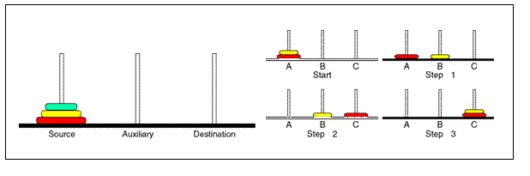

**What is required in this assignment:**

1. Write a recursive C++ program that solves tower of Hanoi Problem for N number of discs.
2. Write a short report about your approach to solve the problem and how you come up with the solution.
3. Write any references you have consulted during the assignment.